

Science Highlights Student Reading

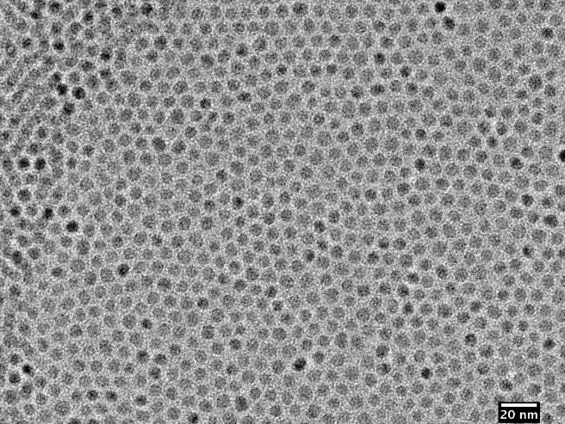**Nanocrystals – small in size, big in impact!**

Figure Transmission Electron Microscope photo of CdSe Nanoparticles that arranged themselves as a thin layer in a grid patten. Each nanocrystal is 5-6 nm - Photo Christian Erickson

A nanocrystal is a particle that has at least one dimension smaller than 100 nanometers. For context, about 10,000-100,000 nanocrystals could fit across a single strand of hair! That’s really tiny!

If a nanocrystal is made out of a semiconductor (a material between a metal and an insulator) and is smaller than 10 nanometers in all dimensions, it is called a quantum dot. Quantum dots emit light of specific colors, and the color is uniquely determined by the material of the quantum dot and its size. Quantum dots’ ability to absorb and emit light have made them useful for biological imaging, designing photovoltaic devices, and enhancing LED technology. Some newer televisions even use quantum dots for high-resolution displays!

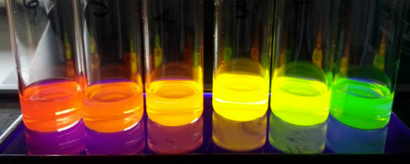Another cool kind of nanocrystal is made of a compound called a zeolite. Zeolite nanocrystals have porous (holey, like a sponge) structures. Depending on the composition of the zeolite, the pores can be many different sizes. Zeolites can be used to filter water or air, or trap molecules for further study; which molecules or pollutants get trapped depends on the size of the pores in the zeolite!

Figure Quantum Dot Fluoresence- Source:Chem461S16Group1-wikimedia.org

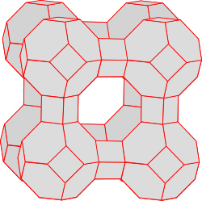

**Check your understanding**

What are two different kinds of nanocrystals?

In what everyday objects or **technology** can you find nanocrystals?

Why might **quantum dots** be useful for solar energy?

Figure Zeolite cage structure

How else might you use a **zeolite nanocrystal**?