

Confocal Microscope Alignment

by Maria Viitaniemi

**A note on this guide:**

In this guide, I draw some conclusions about what is possible to do with certain techniques and what is the easiest way to do certain things, but I don’t always explain why. I also give a specific order in which to do things; this order doesn’t always matter (i.e. whether you set the beam height or direction first). As you work more with optics, you will need to understand *why* things work the way they do, so it is best to start think about that now.

This guide has a companion YouTube video. This video shows what some of these abstract concepts will look like in real life.

**Safety:**

-Always talk to someone more experienced when you begin working with lasers

-Use laser goggles for the necessary wavelengths

-Check for stray beams periodically

-Keep the beam parallel to the table whenever possible. Don’t bend down eye level to the optical table.

-Use low powers to align, especially for beams that are difficult to see

-Never wear reflective jewelry or loose clothing while aligning

-Consider where you could be sending stray beams whenever you insert an optical element, power meter, etc.

**Common Techniques (CT)**

# Single mirror beam alignment

This technique is best suited for rough alignment; two mirror alignment is better for fine alignment. If you must use this for fine alignment, it is best to have a micrometer stage.

Use this technique to get the beam going straight along any path. It is possible to get the bam going level to the table, but it is not possible to set an arbitrary height.

## 

## Pick a path

For alignment, you will need two spots along the path; one should be near the alignment mirror and one should be further away, but within arm’s reach. The height doesn’t matter.

## Place the mirror roughly in place

It should be at the intersection of the current beam path and your desired path. The incoming beam should hit the mirror centered.

## Set the path

### Twist the mirror until the beam is at the far spot

### Move the mirror along the perpendicular axis until the beam is at the near spot

### Repeat steps 1 and 2 until the beam passes through both spots

You should periodically check that the beam is still hitting the mirror centered. If it isn’t, you can slide the mirror along the parallel axis without changing the alignment.

## Set the height

### Use a ruler or card to record the height of the beam at the first spot

### Check how the height of the beam at the second spot compares to the height at the first spot. Tilt the mirror until the beam is at the same height at the second spot

### Repeat steps 1 and 2 until the beam is at the same height at both spots

## Clamp down the mirror

# Two mirror beam alignment

This technique is good for fine alignment. It can get the beam going straight along any path at any height.

## 

## Pick a rough path

## Place the mirrors roughly in place

Use the single mirror alignment procedure on each mirror to roughly get the beam going in the direction you want. Make sure the beam is centered on both mirrors.

## Clamp down the mirrors

## Pick an exact path

For alignment, you will need two spots along the path after both mirror. One spot should be near the alignment mirrors and one should be further away, but within arm’s reach. It is easiest to set two irises. The heights should be the same.

## Set the path and height

### Use alignment mirror 1 to get the beam to spot 1

### Use alignment mirror 2 to get the beam to spot 2

### Repeat steps 1 and 2 until the beam passes through both spots

You should periodically check that the beam is still hitting mirror 2 centered. If it isn’t, you can slide the mirror along the parallel axis without changing the horizontal alignment. If it is too high/low, you will need to adjust the height of the mirror.

# Walking the beam

This technique is useful when you have two alignment mirrors set up. It can be used to very finely adjust the beam path while keeping it parallel to the same axis (see below)

## 

## Decide how much you want to move the beam over

## Move the beam

If the beam is moving over more than a few mm, do this in smaller steps

### Use alignment mirror 2 to move the beam over in the same plane as spot 2

### Use alignment mirror 1 to move the beam over in the same plane as spot 1

### Check that the beam passes through both new spots. Repeat steps 1 and 2 as necessary.

You should periodically check that the beam is still hitting mirror 2 centered. If it isn’t, you can slide the mirror along the parallel axis without changing the horizontal alignment. If it is too high/low, you will need to adjust the height of the mirror.

# Centering lenses

It is important that lenses are well centered on the beam. Otherwise beam quality may be affected.

## Find a spot “far away” along the beam path

An arm’s length is far enough, but may have to be closer depending on the focal length of the lens. The spot should go straight from where you want to place your lens without passing through any additional optical elements. Use an iris or index card to mark where the beam is at this spot.

## Insert the lens and check the spot

The center of the beam should still be passing through the same spot as before. Make sure that the lens is perpendicular to the beam path. If your beam has expanded too much to see where the center is, pick a new spot closer to your lens.

**General useful hints**

# Designing a microscope

-See the confocal microscope alignment procedures for helpful tutorials on choosing lenses and for specific suggestions.

-Use two alignment mirrors whenever possible. Having two makes alignment much easier

-The holes in your optics board are a good reference. Make your beam go parallel the them as often as possible

# Choosing optical elements

-Always check:

-the wavelength range

-the damage threshold

-the flatness rating (if relevant)

# As you’re aligning…

-Leave some strategic irises. They will make re-alignment much easier. Things will drift and get bumped.

-Make sure that before you start all your posts are tight. Also, check that your optical elements are tight, but not so much that they’re warped.

**Confocal Microscope Alignment Procedure**

# I will frequently reference the Common Techniques (CT) section, the optical elements in the microscope diagram, and the axis defined below.

Microscope Diagram:

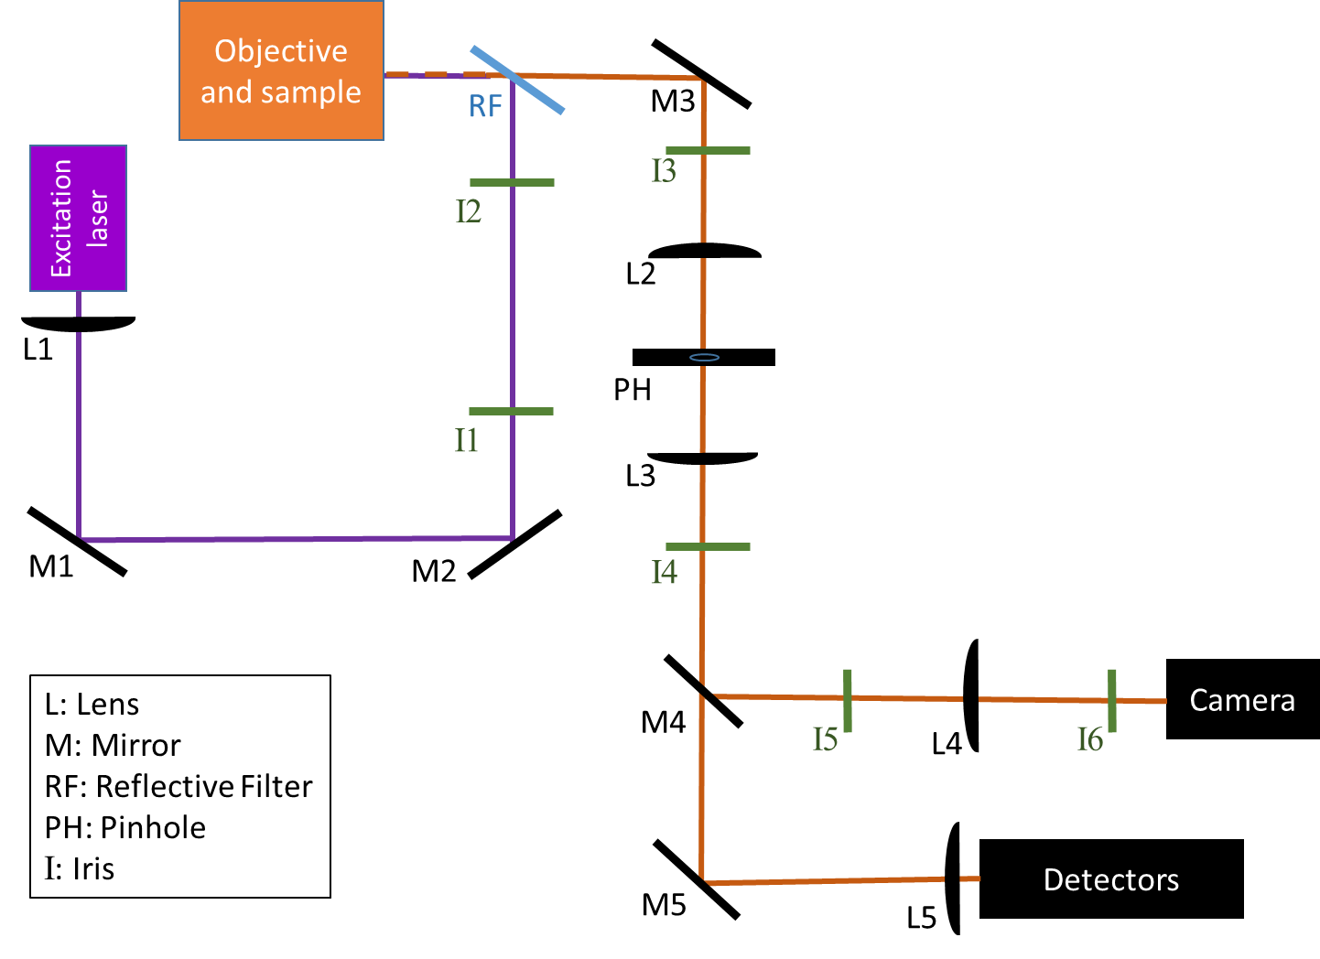

Axis Definitions:

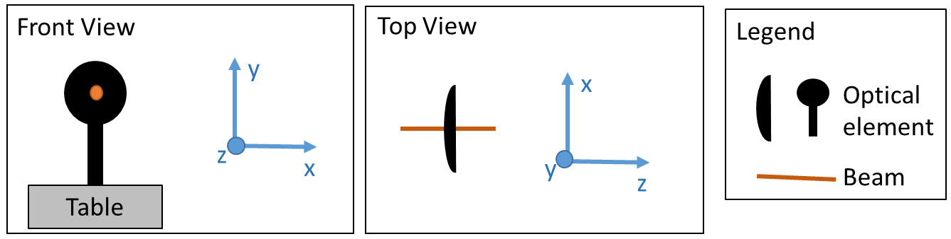

# Prepare the excitation laser beam

## Mount the diode/fiber

Pay attention to the height and rough direction of the beam. Don’t worry too much, but if its ridiculously off alignment will be harder later.

## Collimate the beam

This is necessary for a laser diode or a fiber coupled laser.

### Choose the excitation path collimation lens (L1)

There are some great tutorials on laser collimation that can be found below. Use these tutorials to choose the beam diameter and collimating lens.

<https://www.thorlabs.com/tutorials.cfm?tabID=f7ed0dd5-3f31-4f84-9843-e0f7ac33f413>

<https://www.newport.com/n/focusing-and-collimating>

### Insert the excitation path collimation lens (L1)

Insert the lens in front of the expanding beam. It should be about the lens’s focal length away from the end of the fiber/diode and approximately centering on the beam in the x/y plane.

### Adjust the excitation path collimation lens (L1)

Using an index card or IR card check that the beam is the same size all along the path. The beam should be the same size all the way to “infinity” (a distance long compared to the path lengths in your microscope). It should not pass through a focus point.

## Set the rough beam position

### Make sure the lens is centered

See CT IV.

### Adjust the height and angle of the mount

This isn’t terribly important. You just don’t want things to be so far off that the next steps are unnecessarily difficult.

# Align the excitation beam

## The first alignment mirror (M1)

Use the one mirror alignment procedure (CT, I) to roughly send the beam toward the second alignment mirror.

## The second alignment mirror (M2)

Use the one mirror alignment procedure (CT, I) to roughly send the beam toward the reflective filter (RF).

## Fine alignment

Use the two mirror alignment procedure (CT, II) to set the exact position of the beam. This is a good place to set permanent irises (irises that you will leave there for the life of the microscope).

## Filter and Objective

Depending on your design, you may be reflecting off or pass the excitation beam through the filter. The alignment of the objective is particular to your application. You may need additional mirrors. You will need a way to finely adjust the distance between your objective and your sample.

Depending on your application, consider whether the excitation spot or collection beam is more important in terms of beam quality. Then, if possible, make the beam whose shape is more important the one that is transmitted (rather than reflected). Reflecting off of filters can mess with the beam shape.

Important things to make sure when aligning this portion:

-the excitation beam is centered on the back of the objective

-the excitation beam is passing through the objective straight

Walking the beam is useful for fine adjustments to your alignment to achieve this. If you walk the beam after setting your initial irises, remember to move the irises to the new beam position.

# Align the collection path

## Choose your lenses and pinhole

If the beam is a good size when it reaches your collection path focusing lens (L2), then L2 and L3 should have the same focal length. If you want to expand or shrink you beam, they can have different focal lengths. See tutorials below.

You want to choose a lens that will focus your beam to a nice spot and then collimate it afterwards. There are many factors to consider such as your beam size, the NA of the lens, etc. but there are also many options that will work. If you want to be very precise, you may have to do some Gaussian optics calculations or knife-edge measurements. However, it is often easier to start with something common (i.e. a lens with a 100mm focal length) and then go back and change things if there is a problem.

When choosing a pinhole, a good place to start is with a pinhole that is the size of 1 airy disk for your wavelength. Depending on the strength of your signal and the resolution you are hoping for, you may have to then change to a larger or smaller pinhole. Additionally, you will most likely want the pinhole on a flip mount, so that you can align with or without it.

Irises are useful if you have to switch out optical elements.

Lens tutorial:

<https://www.thorlabs.com/tutorials.cfm?tabID=4BD528B8-11B1-4D32-BE81-CB0C6EBF020C>

Focusing/Beam Expanding tutorial:

<https://www.newport.com/n/focusing-and-collimating>

Gaussian beam optics:

<http://www.rpgroup.caltech.edu/courses/aph162/2007/Protocols/Optics/e3872_Gaussian-Beam-Optics.pdf>

## The alignment mirror(s) (M3)

Use the one or two mirror alignment procedure (CT) to set the beam straight and level down the collection path. This is an important alignment step. The collection path is another useful place to set permanent irises. You want to leave enough space between the irises so that you can fit both lenses (L2 and L3) in between them.

You should also consider how far the collection path focusing lens (L2) if from the objective. If it is too far away the objective, you may lose some of your signal. This would happen if the collected light isn’t coming out of the objective perfectly collimated.

# Set the lenses and pinhole: Method 1

This method uses a power meter to set the pinhole. It is sometimes faster, but not as precise. It also does not allow you to see your beam shape. If possible, I recommend using method 2.

## Set the collection path focusing lens (L2)

Make sure the lens is centered on the beam (see CT, IV).

## Set up a power meter

Place the power meter a short way after the focal point of the lens, but not so far that the beam is too large to fit on the detector.

## Set the pinhole

It is essential to have a mount with fine control in x/y. It is helpful to have a micrometer stage if one if available for find the optimal z position.

### Put the pinhole at approximately centered an L2 focal length away from L2

### Maximize the power using the x/y control

Record or remember the power.

### Adjust the z position of the pinhole.

### Maximize the power using the x/y control

Record or remember the power. Is it power higher or lower than before?

### Repeat steps 3 and 4

Adjust the z position using smaller and smaller step until you find the maximum power. This is where the beam is most focused.

## Set the collection path collimating lens (L3)

Make sure the lens is centered on the beam (see CT, IV). Translate the lens along the z axis until the beam is collimated. It is unlikely that you will see the beam through the pinhole, so you will likely need to flip down the pinhole for this. If you can’t see the beam even without the pinhole, put the lens centered on the beam and a L3 focal length away from the pinhole.

# Set the lenses and pinhole: Method 2

In this method, you will set up a camera to image the pinhole and beam.

## Set a mirror (M4) to send the beam to a camera and set two irises

The beam will be very large for the camera chip. It is possible you won’t be able to properly image the beam because of this.

You will also likely want this mirror to be on a flip mount. This way you will have the most stable beam path (not off of the flipping mirror) for other more important detectors.

## Set the camera focusing lens (L4)

### Set the lens about a L4 focal length away from the camera chip

You can use the second iris (I6) to make sure it is centered.

### Set up a large mirror to image the camera “far away”

You will block the beam. Try to set the mirror so that you can see something (i.e. a sign your friend is holding) on the camera. It does not have to be a high quality mirror.

### Adjust the lens’ z position so that the camera image is focused at “infinity”

You will likely have to start by imaging a notecard close and then move further and further away. The further you can get the better your focus will be. It will also be best if you are using a light source to illuminate the notecard that is similar to the wavelength of your signal light.

It may be helpful to set up a straight edge to keep your lens relatively centered on the beam as you change its z location.

### Clamp down the lens and remove the large mirror

## Set the collection path collimation lens (L3)

Make sure that it is centered (see CT, IV).

## Set the pinhole

Place the pinhole approximately the L3 focal length away from L3. Block the collection beam. Illuminate the pinhole on the side closest to the camera; if possible, use light that is close to the wavelength of the collection beam. Adjust the position of the pinhole until it is in focus on the camera. To see the hole, you may have to adjust the x/y control on the pinhole.

## Set the collection path focusing lens (L2)

Unblock the collection path beam. Mark on the camera screen where the pinhole is and flip pinhole out of the path. Place the L2 lens about an L2 focal length away from the pinhole and center the lens. If all of the lenses are well centered, you should be able to find the image of the beam on the camera. If you can’t see the beam, try taking out all of the lenses (using post collars and leaving their post holders in place) and seeing which element causes problems.

Adjust the z position of the lens until the spot on the camera is as small as possible. It may be helpful to set up a straight edge to keep your lens relatively centered on the beam as you change its z location.

Now check that the beam and pinhole are exactly overlapped by flipping the pinhole in and out. You can adjust the pinhole or the lens. After this you have set the pinhole and will not move it. Once you begin aligning other detectors, move the beam to the pinhole using M3; do not move the pinhole to the beam.

# Final checks and other detectors

## Do you need additional filters?

You may still have some excitation laser reflection making it to the collection path. Depending the type of detector and the size of your signal, this could be a big problem.

## Check the excitation laser alignment using the camera

You will often be able to see some of your excitation laser reflected off the sample surface. This is useful for checking if your excitation laser is well aligned through your objective. Fixing it is similar to walking the beam described in CT.III. You need two alignment mirrors and to be able to watch the laser spot on the camera screen

### Change the focus of your objective by adjusting the distance between your sample and objective

If your excitation beam is going straight through the objective, your laser spot should expand and contract uniformly. If the beam is slightly uncentered or crooked, then the laser spot will bow-tie (asymmetrically expand/contract).

### Use one alignment mirror move the spot off center until you have less bow-tying. Then move the laser spot even further from the center (about half more).

### Use the second alignment mirror to move the spot back to center

Did the bow-tying get better? If yes, keep iterating steps 2 and 3. If no, switch the mirror that you used for steps 2 and 3; then iterate steps 2 and 3.

### Repeat the process with the horizontal and vertical directions as needed

In the end, your laser spot should expand and contract uniformly.

## Additional detectors

The additional detectors you need will be particular to your application. Two common detectors are single photon counters (SPCM) and spectrometers. While the exact set up looks very different for each, the principle of alignment is similar to that of aligning to the camera. You will need a lens to focus the signal onto the face of the detector or fiber. However, since these are much more sensitive detectors the alignment must be much more precise and will often involve cage systems or micrometer stages.