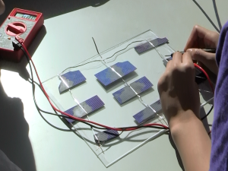**Solar Cells and Solar Panel Workshop Instructors Guide**

In this workshop you will explore the electronics and engineering of solar cells and then design and construct a solar panel.

Objectives

1. Understand the role that photovoltaics can play in our energy future
2. Experiment with solar cells and meters to discover and construct circuit rules
3. Use terminology of electricity volts, amps, watts in context
4. Use series and parallel circuits to design an arrangement
5. Gain experience with the engineering design cycle
6. Practice skills of soldering and work carefully to build a working device

**Instructional Sequence**

1. Introductory Slide Show- (refer to sections after completing each activity- let students discover design principles by experimentation if possible.)
2. Solar Cell Exploration-
   1. Measure the voltage of a variety of solar cells, under a light bulb, in the sun, try covering parts of the cell in one direction and then the other,
   2. Tilting the cells with respect to light source while measuring angle and voltage. Discuss what you have learned about the cells. Record observations on the data sheet.
   3. Series and parallel circuits- use the encased mini cells to try different circuits- measure voltage and current
   4. Try unequal size cells in series and parallel = (parallel tracks must have same area)
   5. Measure current from cell with a diode placed in different orientations
3. Discussion of results and continue presentation presenting rules.
4. Power calculations- Discuss definition of power and generate example of power requirements of different common devices. Calculate the power of sample cells and panels using the formula- P=I X V. Estimate number of cells
5. Panel Design- Define the use you intend to make of the panel. Select the cells and draw a schematic of how the cells will be arranged. Use the worksheet to calculate the voltage and current that you expect your panel to generate in full sun

**Soldered Panel**

1. Arrange the solar cells in the pattern you have chosen on a rigid backing material such as plexiglass or plywood. You may try to cut larger cells into smaller cells so that you have more flexibility to build series circuits. Plan your cuts so that that some of the wide top conductor strip is on each cell piece. Use a diamond tip scribe to repeatedly score the cell along a straightedge guide. Support the cell completely to avoid uneven pressure. If the cell doesn’t split on its own, position the scored line over a table edge ant the gently flex the cell. It hard to get an even repeatable cut but even uneven broken pieces will still work.
2. Soldering- layout the pieces, cut the ribbon tabbing wire, practice on scraps and then carefully build a panel. Apply liquid rosin to the spots where you will solder. Most solar cells have some white spots on the back which are solderable. On the front solder to the wide collector ribbon. Draw the soldering iron along the pre-tinned tabbing wire. Hold it down with a pencil lead. You may have to stop and let the soldering iron tip heat up between lengths. Flip the cell over and solder another piece of tabbing wire to the other side. Test connections as you go and test the whole thing before housing it.
3. To make a complete charger add diode to circuit in the right direction. The striped end of the diode is the cathode, the other end is the anode. The anode should be connected to positive side of the cell (the back).
4. Housing- use hot glue to secure the cell array at a few spots. Solder to the flat ribbon to regular insulated wire with an extra bend and extra glue so it can’t pull loose. Use a dab of hot glue at each corner then gentile press the top plate down without crushing the cells. Apply clear packing tape to the edges to seal the unit.
5. Try it out.

**Simple Solar Panel**

It is possible to connect one or more solar cells with 1/4″ adhesive conductive copper foil tape instead of solder.  This cuts down on the frustration with soldering solar cells.

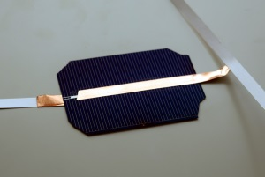

Conductive copper tape connects the front of one cell to back of another.

1. Place the cell flat on a hard smooth surface.
2. Cut a piece of foil tape 1″ longer than the width of the cell. Remove the adhesive backing an position the foil 1/2 ” from one edge of the cell and extending beyond the opposite edge. Carefully smooth it down for maximum contact with the cell conducting grid.
3. Flip the cell over and position another tape to touch the contact points on the back and run if off the edge making sure it doesn’t touch the copper strip on the top.
4. Position the cell on a piece of plastic or rigid polystyrene.
5. Cut a clip lead in two, skin the end, and solder one lead to each extending copper lead. Or press a loop of the wire on the exposed copper strip and seal it with another piece of copper tape.
6. Place a piece of clear laminating plastic over the cell and smooth it down being careful to smooth out air bubbles and using the plastic to secure several inches of the clip lead to the cell.

**Series scraps cell panel**

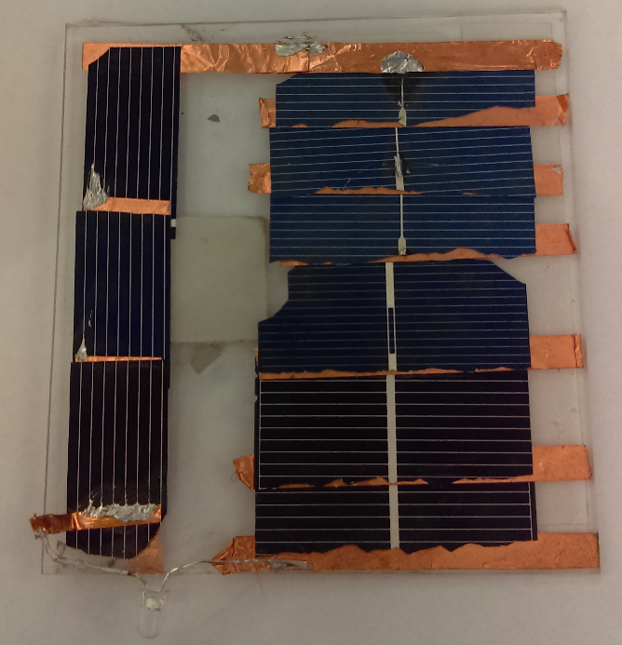This variation scraps of cells are arranged and connected directly top to bottom at the edge using double adhesive copper tape, or wire glue**.

1. Collect a bunch of solar cell scraps approximately the same area. If possible pick ones in which there are still wider collector grid manifolds on the top of the cell.
2. Attach an adhesive copper tape to the back of the first cell. Place it face up on the end of a piece of backing material such as plexiglass rigid plyboard. Orient the top conductor toward the edge where the next cell will sit.
3. Apply a short length of double sided copper tape along the edge at the opposite end of the cell, or apply a bead of conductive wire glue.
4. Place the next cell on top of the adhesive so there is 1/8” of overlap, gently press this to get a good contact. Be careful not to press any unsupported part of the cell for it will surely crack.
5. Repeat for each cell, looping back to the beginning if there is room.
6. Attach a copper tape to the top of the last cell.
7. The series arrangement may a higher voltage but low amperage. This is ideal for lighting a LED or flashing LED.

** Wire glue is a thick paste that contains conductive carbon in a water soluble binder. You can apply drops of the wire glue at each interface point. This makes a good contact and decreases the chance of shattering cells as you press down.

Vocabulary

Solar cell- a single wafer having the characteristic voltage of the basic material

Solar panel- an array of many solar cells, wired in series and parallel and usually encapsulated in a durable container to protect the cells

Diode- and electronic device which allows current to flow in only one direction. This is a necessary part of a battery charging circuit to prevent the battery from discharging into the solar panel at night.

Semiconductor- a type of material which conducts electricity under some conditions but not others

Power- the rate of total energy flow – equal to volts x amps- measured in watts

Voltage- the potential difference or electromotive force- measured in volts

Current- the flow of electrons over time measured in amps

Kilowatt hour- an amount of energy equivalent to 1000 watts expended for one hour.

Parallel circuit- an arrangement in which electricity can flow through more than one path to the same destination

Series circuit- an arrangement in which all electricity must flow through the same single path.

Videos

Soldering solar cells

<https://www.youtube.com/watch?v=NJYaI3NGfXk>

Making a solar panel

<https://www.youtube.com/watch?v=ybvP8vjv1UY>

Materials and tools

Electric Meter

Flat rigid surface

weights for holding down ribbon

solder

flux

wire glue conductive adhesive can connect cells that are sandwiched in series.

<http://www.ebay.com/itm/like/290695765305?lpid=82&chn=ps&ul_noapp=true>

40 watt soldering iron $8.95

[http://www.amazon.com/gp/product/B0006NGZK0/ref=oh_aui_detailpage_o02_s00?ie=UTF8&psc=1shotkey diode](http://www.amazon.com/gp/product/B0006NGZK0/ref=oh_aui_detailpage_o02_s00?ie=UTF8&psc=1shotkey%20diode)

diodes- 3 am 20 pack $8.99

<http://www.amazon.com/gp/product/B0068AF32Q/ref=oh_aui_detailpage_o02_s00?ie=UTF8&psc=13x6>

Encased practice solar cells for exploration- Pitsco

<http://www.pitsco.com/Solar_Mini_Panels>

solar cells- 1.8W $36 for 36

<http://www.amazon.com/dp/B008A090L2/ref=wl_it_dp_o_pC_nS_img?_encoding=UTF8&colid=WH6BS871V8F3&coliid=I3TZB8816BQFYC>

186 soldering flux 3.50

<http://www.amazon.com/gp/product/B00EWLA24C/ref=oh_aui_detailpage_o01_s00?ie=UTF8&psc=1>

tab wire, pre-tinned 200 fit roll $12.95

<http://www.amazon.com/gp/product/B00E28OG8S/ref=oh_aui_detailpage_o03_s00?ie=UTF8&psc=1>

Small electric motor

<http://www.goldmine-elec-products.com/prodinfo.asp?number=G18050>

Small motor with fan blade

<http://www.goldmine-elec-products.com/prodinfo.asp?number=G18541>

Or get a single user set with multiple cells, ribbon, flux and solder…

Solar cell sample kit $14.95

<http://www.siliconsolar.com/solar-cell-sample-pack-p-84.html>