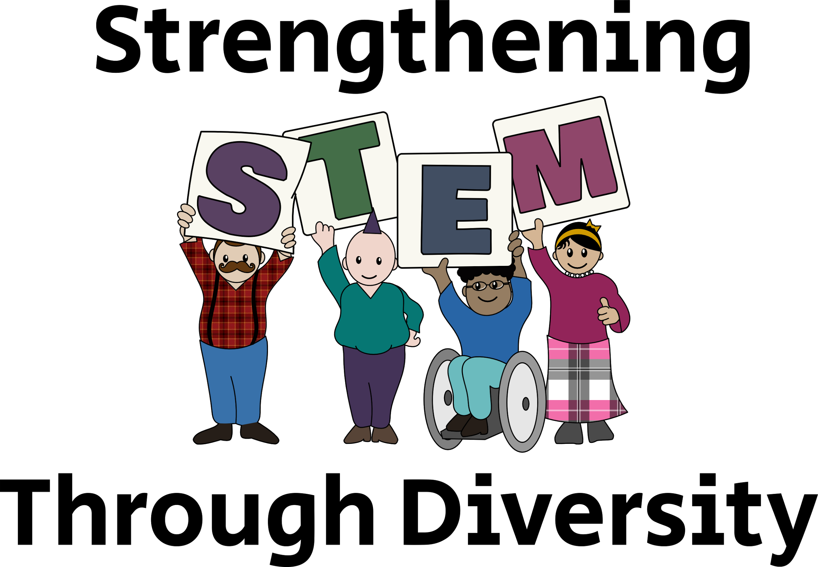

A Planning Guide
Nicholas Montoni and Sarah Vorpahl
Most Recent Version: 06/07/2017

Initial Steps
- Have an idea, and share it with someone! We began by realizing that there were so many diversity-focused groups on campus that weren’t collaborating. We wanted to emphasize our uniqueness and our commonalities.
- Make a timeline and set a date. We gave ourselves about four months. That’s enough time, but too much and we’d have been lazy and too little and we’d have been stressed.
- Keep your planning committee small - no more than three people. Certainly take advice, but don’t let anyone else make decisions.
- Reach out to campus leaders, friends, professors, deans, chairs, and other administrative staff that you know. In general, the campus community is ecstatic to help students plan things.
- Get the hype going. Make a Facebook event. Send out emails to anyone and everyone you can think of. You can’t possibly over hype your event.
- Confirm speakers, panelists, and volunteers ASAP.
- Find and reserve a room of the appropriate estimated size ASAP. We used the HUB Lyceum and it was perfect.
- Most importantly: make this what you and your communities want it to be.

Sample Timeline

Action | Time
Contact groups | end of May
Meet with Grad School (Kelly Edwards and Jaye Sablan) | June 7th
Open Registration | June 15th
Social Media Push | June 15th-end of July
Confirm Speakers/Panelist | August 1st
Close Registration | August 31st
Book Room | Sept 1st
Order Food | Sept 1st
Finalize Workshop | September 15th
Trial Run of Workshop | End of Semptember
Day of the event! | Oct 8th

We gave ourselves 4-5 months to accomplish this. We stuck very closely to this timeline, though the food and registration deadlines were pushed back a bit by the time we got to them. We were ambitious, but it turned out that we needed less time for the food and registration than we thought.

Strengthening STEM through Diversity Schedule
8:30 - 1:30 in the HUB Lyceum, 2:00 - 5:00 in the Allen Library Research Commons

- Registration and Breakfast: 8:30-9:30 in the HUB Lyceum
- Introductions: 9:30-9:45 in the HUB
- Plenary Talk: Wendy Thomas
  - 9:45-10:15 - talk
  - 10:15-10:30 - Q&A
- Panel discussion featuring UW RSOs: 10:30-12:00
  - Joe Camacho - SACNAS
  - Amanda Hayes - AISES/NOIS
  - Brenda Kessenich - oSTEM
  - Heidi Nelson - WCS
  - Viral Shah - UAW 4121
- Lunch catered by Cedars: 12:00-1:30

Transition Time: Find your group and head to the Allen Library Research Commons!

- Workshop! (2:00 - 5:00)
  - First Hour: “Step Up, Step Back”
  - Second Hour: “A Moment of Mentorship”
  - Third Hour: Wrap-Up
    - Dr. Kelly Edwards
    - Dr. Anthony Salazar

Here is our schedule for the day of the event. We planned a plenary speaker, a panel of students, a three-hour workshop, and wrap-up from two university admins/faculty. That was a lot! Our feedback focused on a lot on the shortcomings of the workshop. It seemed to lack momentum which may be true. In planning your own event, you may consider doing a half day, with only speakers and panelists or a workshop, but not both.

The first half of the day focused on diverse identities in STEM - LGBTQ+, gender minorities, and racial/ethnic minorities. The second half of the day focused on how these identities did or did not impact our ability to find good mentorship.

Sample Budget

Food (based on Bay Laurel Catering)
Breakfast | unti cost | amount | total cost
lg fruit (70) | 140 | 1 | 140
dozen bagels w/cc (12) | 25 | 4 | 100
dozen fruit danish (12) | 19 | 2 | 38
gallon coffee (20) | 30 | 3 | 90
gallon tea (20) | 30 | 3 | 90
total |  |  | 458
Lunch | unti cost | amount | total cost
sandwich platter (per guest) | 6 | 100 | 600
caesar bowl (10-15) | 40 | 4 | 160
dozen cookies (12) | 20 | 5 | 100
gallon iced tea (20) | 26 | 3 | 78
gallon iced water (20) | 7 | 5 | 35
total |  |  | 973
TOTAL FOOD |  |  | 1431
Supplies (based on Office Max) | unti cost | amount | total cost
giant notepads (6 pack) | 152.99 | 1 | 152.99
small notepads (12) | 8.49 | 6 | 50.94
markers (8) | 6.29 | 3 | 18.87
whiteboard markers (12) | 19.99 | 2 | 39.98
printing (color) |  |  | 0
program | 0.1 | 200 | 20
flyers | 0.1 | 200 | 20
resource guide/about groups | 0.1 | 600 | 60
name tages (160) | 26.99 | 1 | 26.99
stickers (2500) | 8 | 1 | 8
gift for speakers | 20 | 2 | 40
swag from groups | 0 | 0 | 0
TOTAL SUPPLIES |  |  | 389.77
TOTAL COSTS |  |  | 1820.77

This is the budget we used. This was an underestimate, unfortunately. The food and room were more expensive than we expected. However, we also got much more funding than we expected, so it all worked out! If you plan an all-day event, expect to spend no less than $2000. If you plan a half-day, expect to spend no less than $1000. Ask for funds accordingly.

How did we get funding?

We asked.

name | amount | use | amount used
Clean Energy Institute | $1,000 | breakfast | $993
UAW | $1,000 | lunch | $1000
College of Arts and Sciences | $500 | room | $500
Women in Chemical Sciences | $250 | room/ucar | $250
Graduate School/ GO-MAP | $1,000 | supplies?
Institute for Science and Math Education | $500 | also lunch | $200
total | $4,250 |  | $2,943
 | remaining | $1,307

We also overshot this estimate, but better to have too much than not enough.

How to reserve a room

Depending on the space you need, the path to getting the right room for your event may not be so linear. Our event required two spaces: the HUB Lyceum and the Allen Library Research Commons. For the first room, we booked it through a Registered Student Organization. For the second room, we just asked our contacts at Graduate School Core Programs to get in touch with the administration at Allen Library.

If the space you want is under the jurisdiction of a particular department, college, or institute, go through your contacts there.

Audience Interaction

Lectures and panels can be boring. To make ours a little bit more interactive, we set up an account with sli.do, an app and service that allows anyone to anonymously (or otherwise) submit questions and thoughts to a live feed. We invited the audience to send questions and thoughts for the speakers and panelists throughout the day, and we made time to address questions after each segment of the day.

We also invited guests to tweet pictures and thoughts using the hashtag #DiversifySTEM. Check it out for yourself!

How to Generate “Buy-In”
To get our participants interested in the event, we crowdsourced some of the planning. We sent out publicly available documents prior to the event containing drafts of event goals, event motivation, and even the event title, and asked the participants to contribute. We received contributions from Deans, graduate students, and professors, to name a few, all telling us what they hoped to receive from the event and why they would want to attend an event like this in the first place.

Designing a Workshop
Our workshop was stitched together from many different examples. We did a fair amount of research into different strategies for small group work centered on identity and mentorship. Depending on the focus of your event, different workshop strategies might be useful. We chose a system called “think, pair, share,” in which each participant thinks on their own, pairs up with another member of the group to discuss, and the shares with the whole group. This is a strategy that minimizes the anxiety of presenting in front of groups, as it allows for an opportunity to share and synthesize information between two people, who can then decide who will share with the larger circle.

Getting the Word Out
This was one of the hardest parts of our event. The lesson we learned was: you can never tell too many people about your event too often. That is almost certainly true. Email everyone you know, post about it on Facebook, send the announcements to the Graduate School, campus departments, colleges, and institutes. Print nice flyers and hang them up everywhere that it’s allowed.

More importantly, keep a spreadsheet of who you have contacted and how often. Show it to someone to figure out who you’re missing.

When you’re registering participants, use an online form and be very clear about the event date, time, and location. We made the mistake of using a pre-registration link to gain a sense for how many people were interested. Many participants thought that this was the official registration link, and didn’t fill out the real one when it came through their inboxes a month or so later.

A Final Note
Planning a big event is hard work, but the infrastructure to accomplish it exists already. The UW campus administration is so happy to help students plan and execute these kinds of events, especially ones that are interdisciplinary and focused on inclusion and justice. So, when you’re putting all of this together, you should have fun. Do it because you want to!

Acknowledgements
This event would not have been possible without Sarah Vorpahl, Prof. Kelly Edwards, Jaye Sablan, WCS, oSTEM, SACNAS, ISME, UAW 4121, the College of Arts and Sciences, CEI, GO-MAP, or many, many other people.

