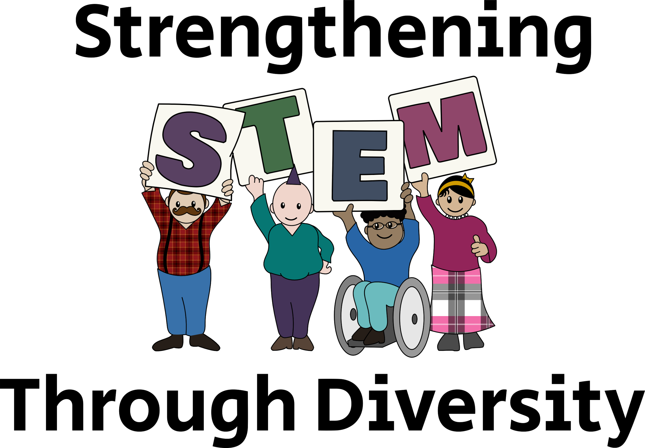
Schedule, Summary, and Follow-Up
October 8, 2016
Nicholas Montoni and Sarah Vorpahl

Motivation:
- Growth mindset towards mentorship
- Commonalities in differences
- “Collecting data” on mentorship
- Representation beyond inclusion

Goals
- To build community for, generate networking opportunities among, and spotlight the value of diversity and the representation of diverse groups in STEM.
- To identify the challenges to diversifying STEM and the needs of underrepresented students and determine actionable solutions.
- To determine best practices for the recruitment, mentorship, and graduation of underrepresented students; identify the means to implement them; and identify ways to distribute this information to those who may not have diversity as a first priority.

Participant Pre-Survey Results

“What do you hope to get out of the event?”

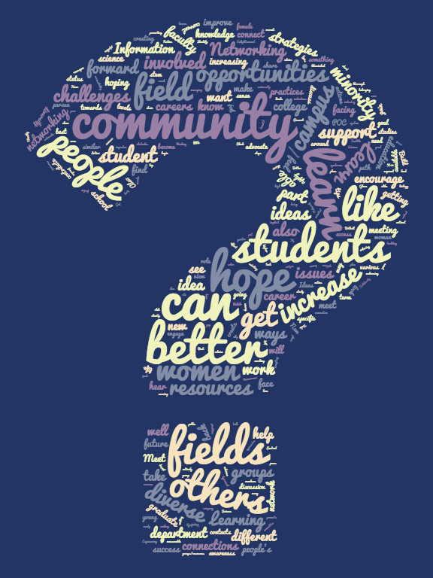

“What are some goals for yourself and your community pertaining to diversity and representation?”

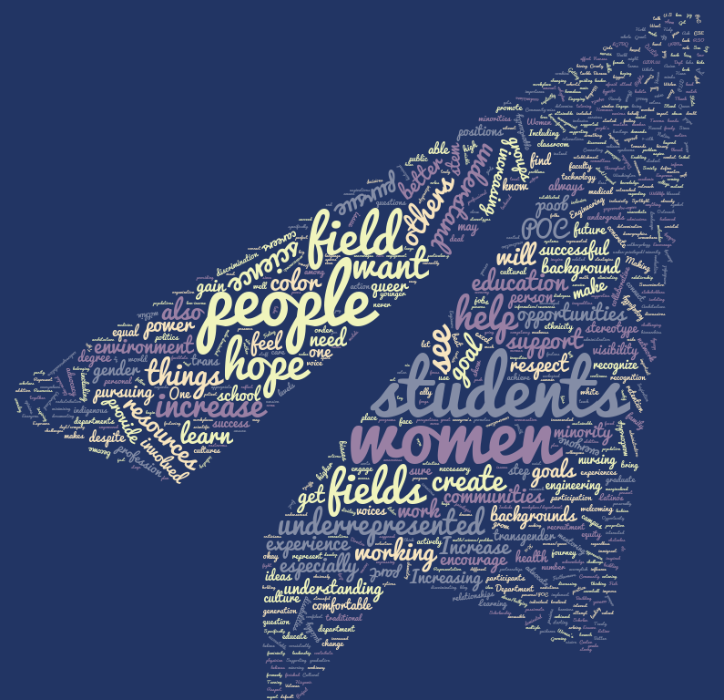

“What does mentorship look like to you?”

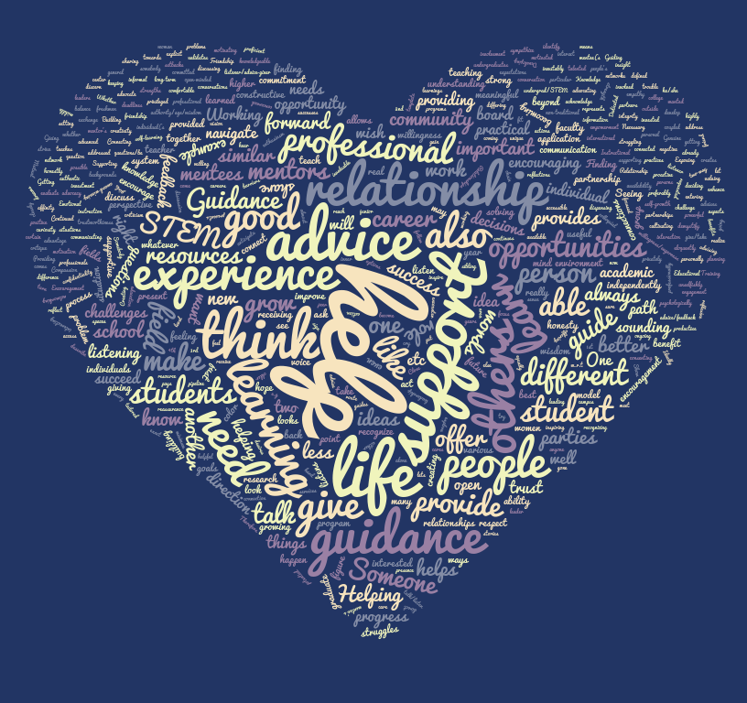

Strengthening STEM through Diversity Schedule
8:30 - 1:30 in the HUB Lyceum, 2:00 - 5:00 in the Allen Library Research Commons

- Registration and Breakfast: 8:30-9:30 in the HUB Lyceum
- Introductions: 9:30-9:45 in the HUB
- Plenary Talk: Wendy Thomas
  - 9:45-10:15 - talk
  - 10:15-10:30 - Q&A
- Panel discussion featuring UW RSOs: 10:30-12:00
  - Joe Camacho - SACNAS
  - Amanda Hayes - AISES/NOIS
  - Brenda Kessenich - oSTEM
  - Heidi Nelson - WCS
  - Viral Shah - UAW 4121
- Lunch catered by Cedars: 12:00-1:30

Transition Time: Find your group and head to the Allen Library Research Commons!

- Workshop! (2:00 - 5:00)
  - First Hour: “Step Up, Step Back”
  - Second Hour: “A Moment of Mentorship”
  - Third Hour: Wrap-Up
    - Dr. Kelly Edwards
    - Dr. Anthony Salazar

Workshop Guidelines
The goal of the workshop is to produce an evergreen resource collection, the most significant document being a proposed “URM Student Bill of Rights.” This Bill of Rights will be something URM students can share with their advisors, mentors, and graduate programs in order to receive the support and help they need to succeed. We also hope that the resource collection will serve to help URM students find a support network outside of and in addition to their graduate program.

The workshop will be breakout-style. For the sake of demonstration, suppose there will be 80 attendees at the summit. The 80 attendees will be broken into four groups of twenty and split into four rooms. In these rooms, the attendees will again be split into groups of five (likely by a colorful sticker on their nametags or some other fun organizational tool). In each room, there will be large notepads with big, overarching questions about mentorship, support, networking, challenges, and successes. Each group will brainstorm answers, speaking from their own experiences, and each room will record the salient points. Then, each room will come back together and as a whole summit we will compile the information and resources we’ve collected and created.

Possible Workshop Questions
- What do you need to succeed in your field?
- What is your greatest challenge?
- What have you done to overcome challenges?
- Who has helped you succeed so far?
- What resources have you used?
- What resources do you wish existed for you?
- What are the benefits of having a peer support group?
- What are the benefits of having a mentor/advisor who is “on your team”?
- If you could send any message to yourself as you started your graduate program, what advice would you give?

Not all of these questions can be a part of the workshop, because that’s a lot of questions to answer in a short time. It seems to make sense to do four or five questions during the workshop, but all of these questions are very pressing and important! And I’m sure there are even more that we haven’t listed. That’s why after the workshop, during the wrap-up and compiling of information, we plan to pose this extensive list of questions to the attendees so that we can continue to collect information. In fact, it may be useful to send this list home with the attendees and collect responses at a later time in order to keep the brainstorming going.

Goals for the Summit
1. To identify the challenges to diversifying STEM and the needs of
underrepresented students and determine actionable solutions.
2. To build community for, generate networking opportunities among, and spotlight
the value of diversity and the representation of diverse groups in STEM.
3. To determine best practices for the recruitment, mentorship, and graduation of
underrepresented students; identify the means to implement them; and identify
ways to distribute this information to those who may not have diversity as a first
Priority.

Links to Facilitator Guides
Here are some links to some reasonably useful guides. Even though there is a more of a business slant to some of them, there are also some examples that can be adapted to help with this workshop.

Also, please add more ideas in this document! Feel free to add segues or discussion starters in the outline below for specific parts of the workshop. Also, you can add to the “rainy day” topics list here as well!

Links:
http://www.workshopexercises.com/Facilitator.htm#Facilitators Guide

http://www.workshopexercises.com/DiscussionTips.htm

http://www.teindia.nic.in/files/teacher_trg_module/8_creative_facilitation_techniques.pdf (skip to page 27 for ideas about brainstorming).

http://oqi.wisc.edu/resourcelibrary/uploads/resources/Facilitator%20Tool%20Kit.pdf

“Rainy Day” topics:
Relate back to an experience you have had or ask someone to expand on something they have said.

Tie back into conversations from other part of the event (panel discussion, plenary talk)

Change up directions! Flip the conversation around and ask them to put themselves in the shoes of the mentor/other person in the story. What could they have been going through or thinking about during the interaction? Are there other explanations for behavior that can workshopped?

Workshop outline for facilitators

Groups will be 8 people including 1 facilitator, who will also participate in all activities.
After lunch facilitators will gather their groups in the HUB Lyceum (using symbol on name tag) and walk over to research commons. We will provide an assigned area for each group.

- Introduction activity

  - Intros: Facilitator begins by forming everyone into a circle and asking them to say their name, where they are from (department, office, etc) and their role.
  - Facilitator will ask for a verbal agreement from the group that experiences discussed will remain confidential. They also let the group know they should feel free to not answer any questions during the activity.
  - Facilitator reads a list of statements, asking the participants to step forward into the circle if they identify with the statement. The facilitator should ask the participants to think about the statements in relation to their experiences in work/lab/school environments. They should instruct the participants to reflect on specific experiences and note the different people stepping in and out of the circle during the activity (10 min)

    - You have felt like an outsider amongst your peers.
    - You have felt that your opinion is undervalued.
    - Your mentor does not look like you.
    - Your peer group does not look like you.
    - I feel unable to discuss my identity among my colleagues.
    - A coworker or mentor has said something insensitive to me.
    - A coworker or mentor has assumed something about me that is untrue.
    - A coworker or mentor has assumed something about me that was private.
    - You have tried to change your appearance, mannerisms, or behavior to avoid being judged or ridiculed.
    - You have felt not fully supported by your parents or family because of your identity.
    - You have felt physically threatened or unsafe at work.
    - You have felt guilty or ashamed for having to prioritize other obligations over your work.

- First discussion: Challenges

  - Ask the group to think about the following questions: What were you thinking as you moved? How do you feel about yourself relative to others? Which of these statements hurt and why? Which of the statements did you find most meaningful and why?
  - Now ask participants to pair up. Have the pairs discuss specific experiences and challenges that came to mind as a result of the questions. Have both participants take notes (if they want). (20 min)
  - Have everyone return to the group. Ask pairs to share the challenges and experiences they discussed with each other and any insights or needs that they thought of with the whole group. The facilitator writes as everyone discusses these ideas into a “web” of challenges and needs. (30 min)
- Dissecting a moment of good mentorship (Worksheet)
  - Facilitator hands out worksheet and instructs participants to recall a specific challenging moment, perhaps one that was just discussed, where a mentor or team of mentors helped them. If there was not a mentor to help, tell participants to imagine what a mentor could have done to help them.
  - Again, facilitator will remind the group that experiences discussed will remain confidential and worksheets are anonymous.
  - Have the group write individually for 15 mins.
  - Ask the group to return to the circle and pair up. Have participants discuss in the pairs how their mentor helped them/how they wish a mentor had helped them. (20 min)
  - Facilitators will ask everyone to return to the group and share their ideas about mentorship that were discussed. Try to ask specific questions and write down a list with one side being mentoring that worked and the other side being something that was lacking in mentorship. (30 min)

some ideas for specific questions
i Who was involved (peers, faculty, staff, coach?)
ii Were there multiple types of people (i.e. peer and faculty? a community of people?)
iii What was the medium that was used to help you (i.e. email, text, in person)?
iv. What has made this mentorship experience a lasting success? v. v. What have you learned that you could apply to later experiences?
vi. How did the mentor(s) help make this a safe place to share the challenge you faced?
vii. Have you used that lesson/leaned on that mentor for subsequent situations?

f. After going around the group and discussing mentorship, please bring the paper/whiteboard to gathering place in the back of the room. Kelly Edwards will be looking over all the responses and present some of the common themes she sees.

10-15 minute break

g. Kelly presents
h. Anthony presents
i. wrap up.

Sensitivity and Privacy
Just a reminder that many of the topics that may come up are very sensitive and hard to talk about for participants. In fact, this may be the first time a participant has shared an experience with strangers. Some things to consider:

- Respect—Give undivided attention to the person who has the floor (permission to speak).
- Confidentiality—What we share in this group will remain in this group. Make this known verbally at the beginning of your session and get verbal confirmation from participants that they will keep conversations private.
- Right to pass—It is always okay to pass (meaning "I'd rather not" or "I don't want to answer"). Again, make this know to the group.
- Nonjudgmental approach—We can disagree with another person's point of view without putting that person down.
- Taking care to claim our opinions—We will speak our opinions using the first person and avoid using 'you'. For example, "I think that kindness is important." Not, "You are just mean."
- Sensitivity to diversity—We will remember that people in the group may differ in cultural background, sexual orientation, and/or gender identity or gender expression and will be careful about making insensitive or careless remarks or speaking for others and their own experiences.

Post-Event Comments

“Sarah and Nick, you both did an excellent job organizing and hosting this event. It was well laid-out, tech was incorporated seamlessly (sli.do), and it was a very welcoming environment in which I felt comfortable being vulnerable. In summary, your workshop met all the goals that workshops often aspire to achieve. Well done.”

“I thought you picked a super relevant speaker. She did a great job talking about the role of mentorship in diversifying STEM, and she clearly talked about the dimensions of identity and how they influence a student's time in STEM fields.”

“I loved the personal interaction created by sitting at a table in the Lyceum, the opportunities for small group conversations created during the afternoon workshop, and the time to chat while forming our groups and walking over to the research commons.”

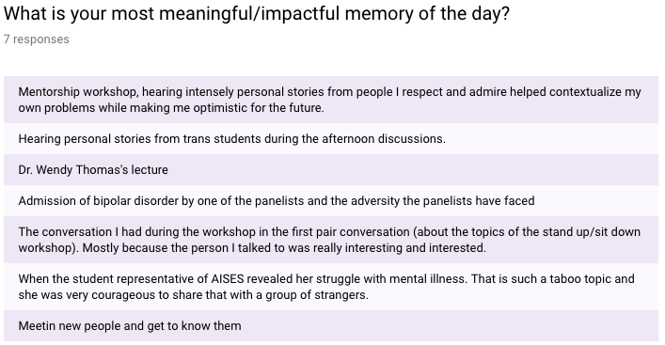

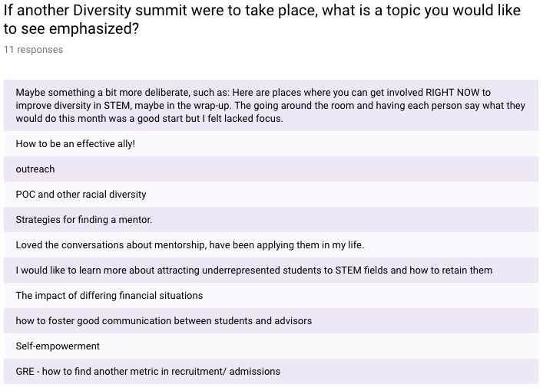

THANK YOU!

Acknowledgements
This event would not have been possible without Sarah Vorpahl, Prof. Kelly Edwards, Jaye Sablan, WCS, oSTEM, SACNAS, ISME, UAW 4121, the College of Arts and Sciences, CEI, GO-MAP, or many, many other people.

Bonus Resources

https://www.aps.org/programs/lgbt/upload/LGBTClimateinPhysicsReport.pdf

https://www.nsf.gov/statistics/2017/nsf17310/digest/about-this-report/

https://www.acs.org/content/acs/en/membership-and-networks/acs/welcoming/diversity.html

