Name:________________________
Make Your Own Solar Cell!

- Match the component to the task:
Task: Component:

- Transparent anode -Berry juice
- Transport electrons -Titanium dioxide particles
- Absorbs light -Carbon-coated slide
- Transport positive charges -FTO glass slide
- Cathode -Iodine electrolyte solution
2. Draw a side-view of your cell and label each slice with a task from above

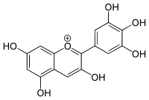
3. Circle which molecule will most likely chelate to titanium dioxide (TiO₂). (Remember chelate means to attach to a metal center in two or more places)
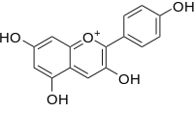

Pelargonidin Delphinidin
4. Time to test your device! (Power=Current (A) x Voltage (V))

Current (A):_____________ Power:_____________

Voltage (V):_____________

5. Cover the light on your device. These are now your “dark” values:

Dark current (A):_____________

Dark voltage (V):_____________

6. Compare you results with other groups. Why might some devices have higher power output? Was there a difference between berry types? How could berry type effect the power output?

