Make Your Own Solar Cell
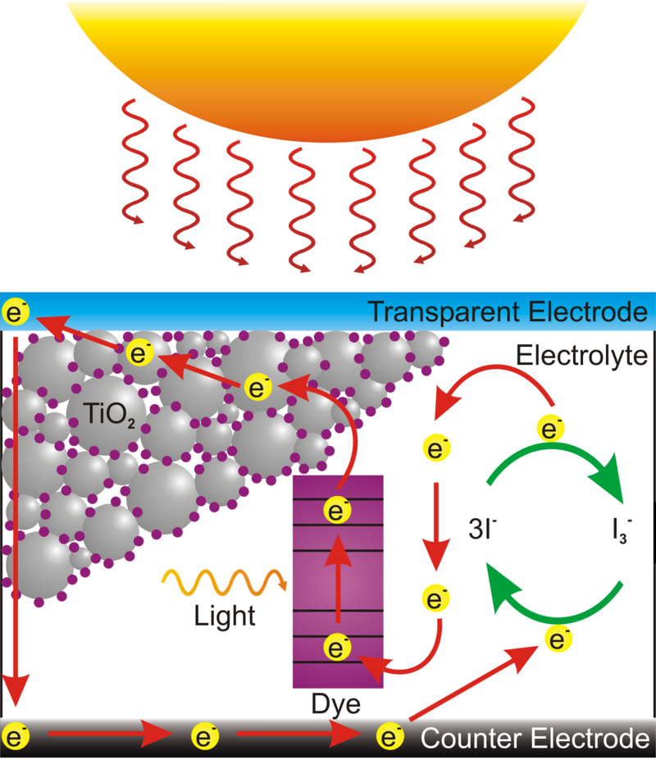
Supplies:
- Titanium oxide (TiO₂) coated FTO slides
- Mortar and pestle
- Berries
- Distilled water
- Petri Dish
- Tweezers
- Ethanol or isopropanol
- Conductive glass slide
- Graphite pencil
- Iodide electrolyte solution
- Binder clips
- Multimeter with alligator clip leads

Procedure:
Part 1: Staining the TiO₂ with Anthocyanin Dye
- Use a mortar and pestle to crush 3-4 berries. Transfer to a Petri dish.
- Add about a tablespoon (15mL) of distilled water to the crushed berries and stir with a clean glass rod
- Take the TiO₂ coated slide and place it TiO₂-side down into the berry mixture
- Let the slide soak for 10 minutes in the berry juice. The film should be stained bright purple/pink. If any white TiO₂ remains, return the slide back to the juice for another 10 minutes. (You can go onto Part 2 while you wait for the slide to stain)
- Lift the slide out of the juice using tweezers. Rinse the slide first with distilled water, then rinse with ethanol. Blot the slide dry with a tissue.
Part 2: Carbon Coating the Counter Electrode
- Determine the conductive side of a FTO coated glass slide using a multimeter. Set the meter to measure Ohms and put both leads on one side of the slide, if the resistance measured is near zero, that is the conductive side.
- Place a piece of tape over one edge, covering about 4mm of the slide
- Use a graphite pencil to cover the conductive side with a thin layer of graphite (conductive carbon) and remove the tape.
- The carbon coating is fragile and can be easily rubbed off. Be careful not to touch it.
This carbon acts as a catalyst for converting triiodide to iodide. A catalyst is a substance that increases the rate of reaction without being consumed.

Part 3: Assembling the Solar Cell
- The berry-stained TiO₂ slide and the carbon-coated slide will be sandwiched together to make the solar cell.
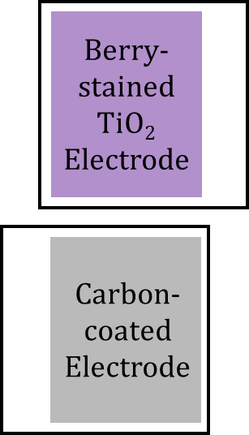
- Identify the clean 4mm strip on each slide. These strips will be connected to alligator clips to test your cell. Orient the strips so that are on opposite sides as shown.
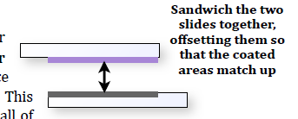
- Place the carbon-coated slide on the table face up. Place the berry-stained slide on top of it so that the coated areas match up and are touching with a 4 mm strip on each side, shown below.

- Pick up the slides in this orientation, careful not to let them move. Clip the edges (the two without the 4mm strip s) with binder clips to hold the cell together.
- Remove one binder clip and place 1 or 2 drops of iodine electrolyte solution at the edge of the slides. Re-clip the slides together.
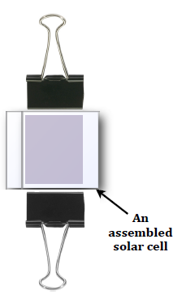
- Alternately open and close each side of the solar cell by releasing and returning the binder clips. Make sure that all the stained area is wetted with this solution. Make sure the binder clips are just on the edge of the cell not covering the coated area.
- Wipe off excess electrolyte solution with a small amount of ethanol on a tissue. Make sure there is no electrolyte solution on the 4mm strips where the alligator clips will attach.
Part 4: Testing Your Solar Cell
- Use a multimeter and attach the alligator clips to your cell: one clip on each side.
- Turn the multimeter to measure current (A). Note the current before placing your cell under the lamp.
- Place your device under the lamp and write down the current measured.
- Turn the multimeter to measure voltage (V) and note this value with and without the light.
If the numbers changed you successfully made a working solar cell!

